2025 RCBO COLORING CONTEST

Name: (Please Print) ___________________________________________________

Age: ___________________ Phone Number: ________________________________

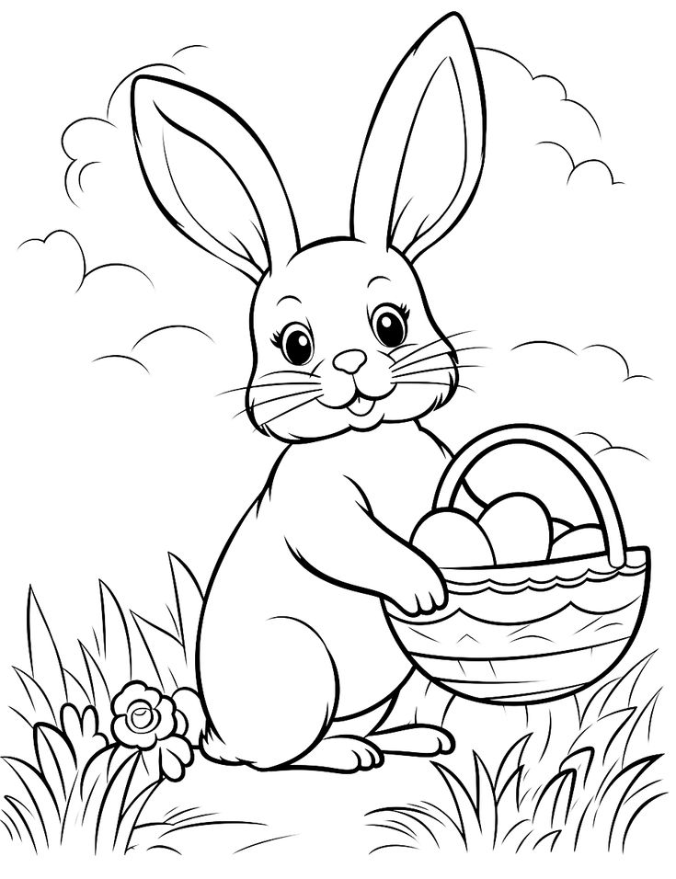

**Must be mailed by April 6th** to: RCBO Coloring Contest

PO Box 217

Franksville, WI 53126

Creativity Judged by Non-Members 3 age categories (3/4 5/6/7 8/9/10 )